
AIC, MATHEMATICS LEARNING AREA
YEAR 11 MATHEMATICS APPLICATIONS – UNIT 2
Assessment type: Response
TASK 9 – TEST 6
Applications of trigonometry

MARKING KEY

TIME ALLOWED FOR THIS PAPER

Reading and Working time for this paper: 50 minutes in class under test conditions

MATERIAL REQUIRED FOR THIS PAPER

TO BE PROVIDED BY THE SUPERVISOR
Question/answer booklet.

TO BE PROVIDED BY THE CANDIDATE
Standard Items: pens, pencils, pencil sharpener, highlighter, eraser, ruler, drawing templates

IMPORTANT NOTE TO CANDIDATES
No other items may be taken into the examination room. It is your responsibility to ensure that you do not have any unauthorised notes or other items of a non-personal nature in the examination room. If you have any unauthorised material with you, hand it to the supervisor before reading any further.

Structure of this paper

Section | Number of questions available | Number of questions to be attempted | Suggested working time (minutes) | Marks available
Calculator Assumed | 7 | 7 | 50 | 42
 |  |  | Marks available: | 42
 |  |  | Task Weighting | 7%

Instructions to candidates
- The rules for the conduct of this examination are detailed in the booklet WACE Examinations Handbook. Sitting this examination implies that you agree to abide by these rules.
- Answer the questions in the spaces provided.
- Spare answer pages can be used. If you need to use them, indicate in the original answer space where the answer is continued.

SCSA Content – Topic 2.2: Applications of trigonometry

    - Use trigonometric ratios to determine the length of an unknown side, or the size of an unknown angle in a right-angled triangle
    - Determine the area of a triangle, given two sides and an included angle by using the rule $area=\frac{1}{2} absinC$, or given three sides by using Heron’s rule, and solve related practical problems
    - Solve problems involving non-right-angled triangles using the sine rule (acute triangles only when determining the size of an angle) and the cosine rule
    - Solve practical problems involving right-angled and non-right-angled triangles, including problems involving angles of elevation and depression and the use of bearings in navigation

TO BE AWARDED FULL MARKS ALL WORKING OUT AND CALCULATIONS MUST BE SHOWN

Question 1 (4 marks)
(a) 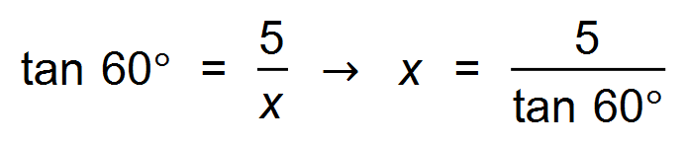
∴ x = 2.89 m
(b) 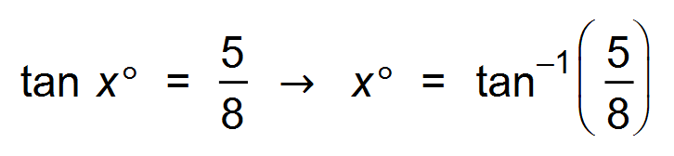
∴ x = 32.01°

Question 2 (3 marks)

Solution
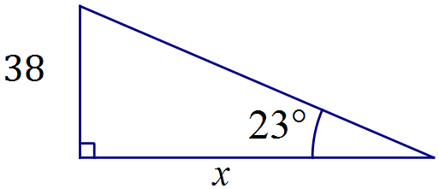

$$\tan{23}=\frac{38}{x}⇒x=89.5 \text{m}$$

Specific behaviours
sketch diagram with measurements
uses tangent ratio
states distance

Question 3 (9 marks)
(a) 208°T
(b)
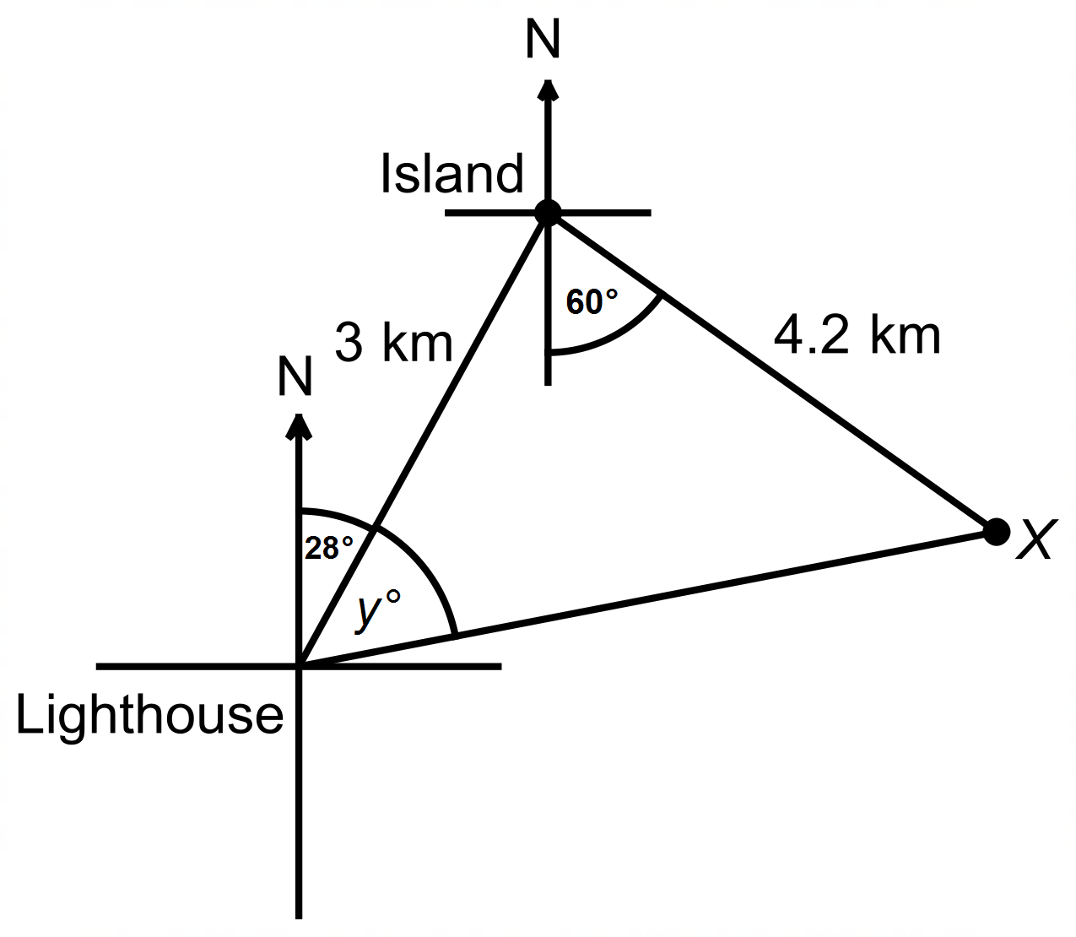

(c) 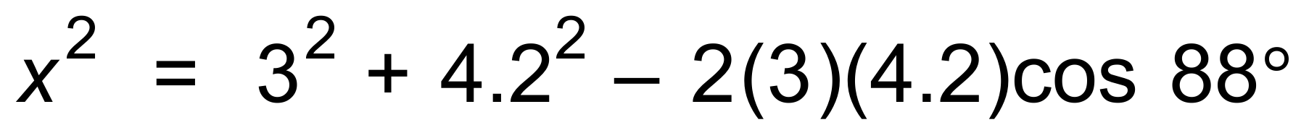
∴ x = 5.075 km
(d) 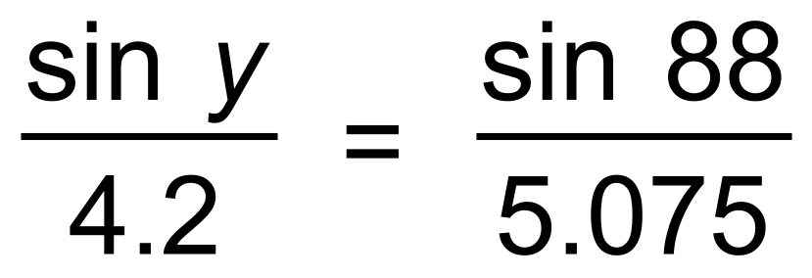
∴ y = 55.8°
∴ Bearing is 56 + 28 = 084°T

Question 4 (7 marks)
(a) 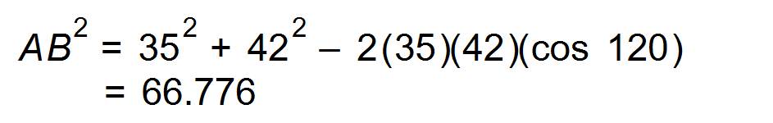
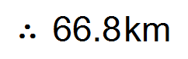
(b) 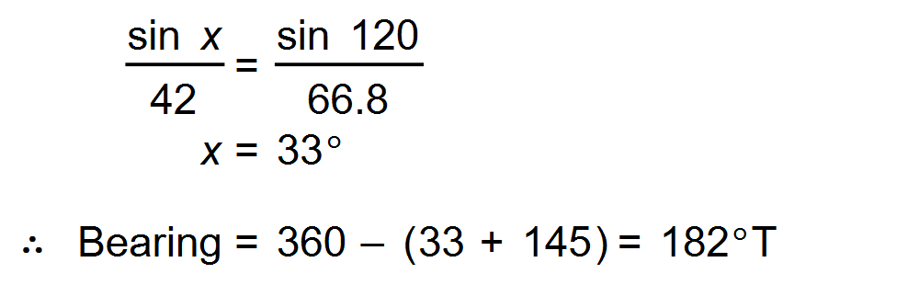
(c) 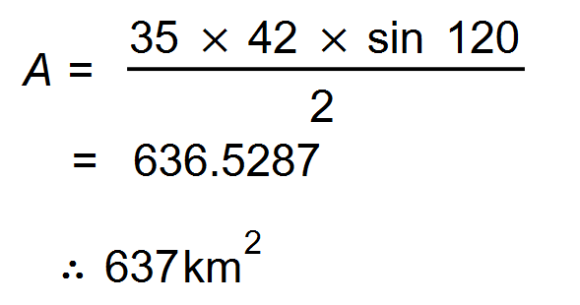 [7]

Question 5 (7 marks)
(a) 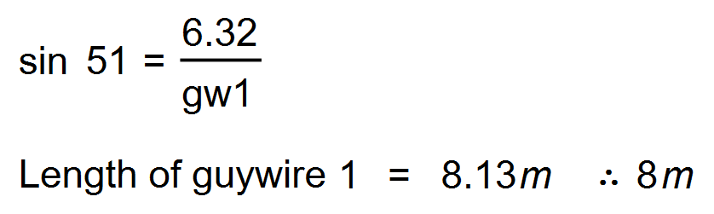
(b) 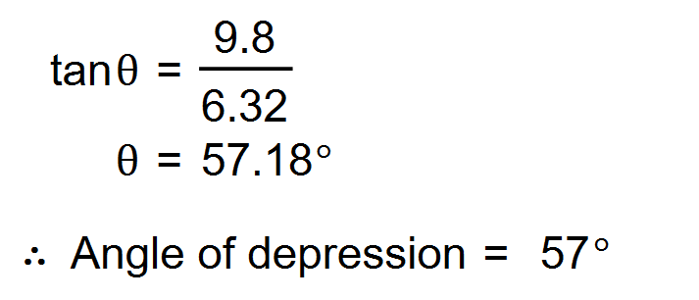 [4]

Question 6 (8 marks)
(a) Sketch a diagram to show the above information. (2 marks)
Solution
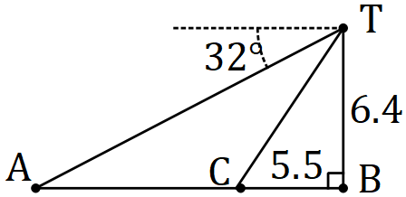

Specific behaviours
vertical $TB$ with angle of depression to $A$
✓ lengths $TB$ and $BC$, making a right-angle

(b) Calculate the line of sight distance from the top of the pole to $A$. (2 marks)
Solution
$$AT=6.4÷\sin{32} \\ =12.1 \text{m}$$

Specific behaviours
uses sine ratio
✓ correct distance

(c) Determine the angle of depression from $T$ to $C$. (2 marks)
Solution
$$∠TCB=\tan^{-1}{\frac{6.4}{5.5}} \\ =49.3°$$

Specific behaviours
uses tangent ratio
✓ correct angle (to nearest degree)

(d) Calculate the distance travelled by the animal from $A$ to $C$. (2 marks)
Solution
$$AB=6.4÷\tan{32}=10.2 \text{m}$$

$$AC=10.2-5.5=4.7 \text{m}$$

Specific behaviours
calculates $AB$
✓ calculates $AC$

Question 7 (7 marks)
(a) 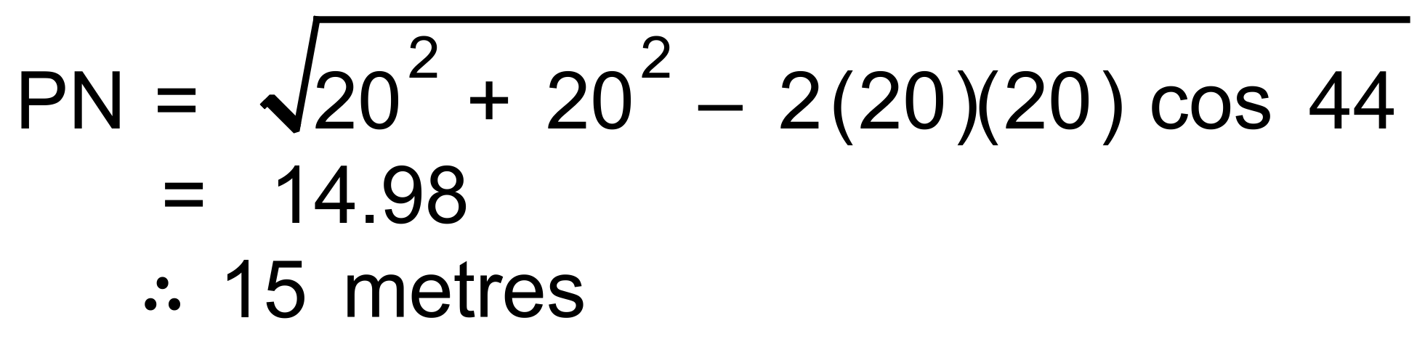

(b) 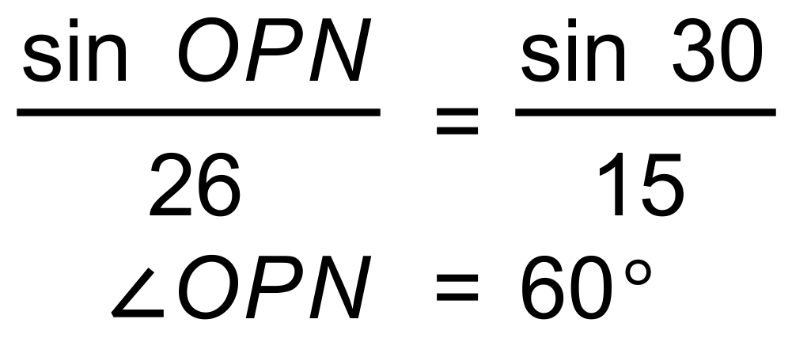

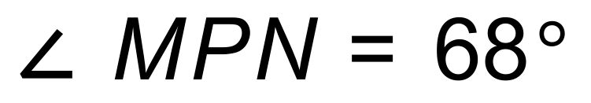since isosceles

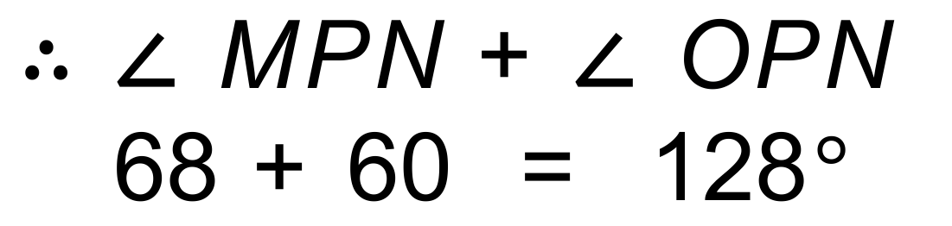

(c) 